WAG PRE-LEVELS GOLD – FLOOR (1)
Statics | 1. © Floor Sequence – Arch, Dish, Candlestick to stand | 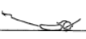 | 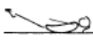 |  | 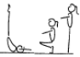 |  | - all positions must be performed with control and awareness  - maintain good body tension and alignment  - head neutral
 | 2. Floor Sequence – front support, rear support, Pike, Closed Pike, Dish, Candlestick, Stand | 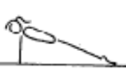 |  | 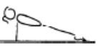 |  | 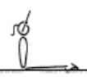 |  | 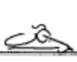
Locomotion | 1. Seal Rolls – arch to dish – no hands or feet touching
Fwd Roll  (for front salto) | 1. Fwd roll to straddle
 | 2. Fwd roll to pike
 | 3. © Fwd roll to squat
Handstand (for walkover, handspring and flic flac) | 1. Angry Cat/Happy Cat position – hold 20 secs
 | 2. Angry cat on floor, turn toes under and straighten legs – keep chest in – back rounded – hold 20 secs
 | 3. Angry cat on a box – hold 20 secs
 | 4. © Angry cat on a box, turn toes under and straighten legs – keep chest in – back rounded – hold 20 secs
 | 5. F1-2.5 Have the gymnast perform small tuck bounces to tuck handstand position on a low box | 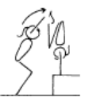 |  |  |  |  | - maintain good body tension and alignment  - hips under, chest in and head neutral  - fingers spread to assist in balance and give a  - broader base of support (middle finger should face  - slightly inward)  - emphasise to the gymnast the importance of  - keeping their hips in line with their wrists,  - shoulders and middle body  - can also be performed in straddle and pike
 | 6. F1-2.4 From a tuck position, jump to tuck handstand, rebound off the floor to tuck handstand x 10, non stop | 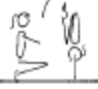 |  |  |  |  | - arms straight  - chest rounded, extended through the shoulders  - good closure during tuck, pike and straddle  - hips open  - gluteal muscles squeezed  - head neutral  - maintain good body tension and alignment
 | 7. F2-1.1 45’ handstand against the wall – hold 10 secs | 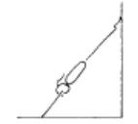 |  |  |  |  | - arms straight  - chest rounded, extended through the shoulders  - hips open  - gluteal muscles squeezed  - head neutral  - maintain good body tension and alignment
Cartwheel / Roundoff | 1. F1-4.3 With hands on a raised surface, perform a cartwheel over and back | 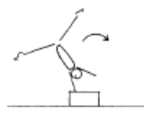 |  |  |  |  | - hands parallel, straight arms  - head neutral  - feet close to hands  - small straddle during the jump
 | 2. © F2-3.1 Side cartwheel to side handstand position, the coach checks the posture and alignment | 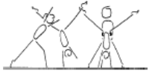 |  |  |  |  | - keep shoulders and hips square  - lunge into the side handstand  - head neutral  - maintain good body tension and alignment
 | 3. F2-3.2 Same as drill F2-3.1 – now have the gymnast rock back and forth
 | 4. Cartwheel using a large ‘chalk-drawn’ circle
 | 5. F1-4.4 Cartwheel through hoops, stretch the hoops out to encourage the cartwheel to be performed in a straight line | 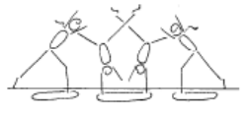 |  |  |  |  | - maintain good body tension and alignment  - pass through a plie into and out of the skill  - hands parallel, straight arms  - head neutral  - small straddle  - keep arms by ears all through the skill
 | 6. Cartwheel from a raised surface (bench or box) to the ground

WAG PRE-LEVELS GOLD – FLOOR (2)
Backward Roll (for back salto) | 1. F2-4.1 Have the gymnast lie on their back on a supersoft mat, their head is just off the edge, the gymnast places their hands on the floor and performs a backward roll. | 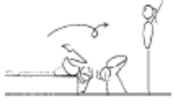 | - confidence and understanding  - legs together  - land on feet and stand  - use hands effectively
 | 2. F2-4.3 Backward roll down an incline – can vary the start and finish positions | 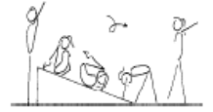 | - confidence and understanding  - legs together  - land on feet and stand  - use hands effectively  - roll in a straight line
 | 3. Beginning in candle stick coach turns gymnast over to deep squat
Stride Leaps | 1. F2-2.1 Have gymnasts “leap” across hoops which are spaced out on the floor | 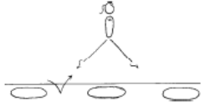 | - emphasise rhythm and form  - chin up, eyes down  - arms symmetrical  - hips and shoulders square
 | 2. F2-2.2 Have gymnasts “leap” over higher (approx knee height) obstacles | 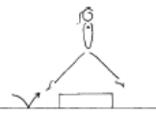 | - emphasise rhythm and form  - chin up, eyes down  - arms symmetrical  - emphasise lifting the back leg  - hips and shoulders square
Leaps/Jumps | 1. © Attitude Steps | 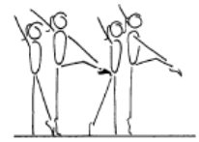 | - one arm moves to low oblique to touch the top of the opposite knee, the other arm repeats the same pattern  - support leg is straight  - the free leg is turned out and the knee is lifted to hip height  - steps are to be performed on toes  - hips under, stomach pulled in  - head up, eyes down  - good rhythm  - stable balance
 | 2. Chasse – alternating feet
Turns | 1. © Side passé, fwd passé releve & turn holding onto something stable – for beginning and end of turn
 | 2. Straight jump ½ turn
FWO, BWO & Tic Toc | 1. F2-5.1 Stand in front of a wall, perform back arch to contact hands on the wall and return to stand | 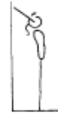 | - keep hips in line with feet  - stretch up first then open shoulders to initiate the back arch  - keep gluteal muscles tight  - maintain good body tension and alignment
 | 2. Shoulder stretch with hands on raised surface – shoulders towards ground – no coach pressure

MAG PRE-LEVELS GOLD – FLOOR (1)
Statics | 1. © Floor Sequence – Arch, Dish, Candlestick to stand |  |  |  |  |  | - all positions must be performed with control and awareness  - maintain good body tension and alignment  - head neutral
 | 2. Floor Sequence – front support, rear support, Pike, Closed Pike, Dish, Candlestick, Stand
Locomotion | 1. Seal Rolls – arch to dish – no hands or feet touching
Fwd Roll  (for front salto) | 1. Fwd roll to straddle
 | 2. Fwd roll to pike
 | 3. © Fwd roll to squat
Handstand (for walkover, handspring and flic flac) | 1. Angry Cat/Happy Cat position – hold 20 secs
 | 2. Angry cat on floor, turn toes under and straighten legs – keep chest in – back rounded – hold 20 secs
 | 3. Angry cat on a box – hold 20 secs
 | 4. © Angry cat on a box, turn toes under and straighten legs – keep chest in – back rounded – hold 20 secs
 | 5. F1-2.5 Have the gymnast perform small tuck bounces to tuck handstand position on a low box |  |  |  |  |  | - maintain good body tension and alignment  - hips under, chest in and head neutral  - fingers spread to assist in balance and give a  - broader base of support (middle finger should face  - slightly inward)  - emphasise to the gymnast the importance of  - keeping their hips in line with their wrists,  - shoulders and middle body  - can also be performed in straddle and pike
 | 6. F1-2.4 From a tuck position, jump to tuck handstand, rebound off the floor to tuck handstand x 10, non stop |  |  |  |  |  | - arms straight  - chest rounded, extended through the shoulders  - good closure during tuck, pike and straddle  - hips open  - gluteal muscles squeezed  - head neutral  - maintain good body tension and alignment
 | 7. F2-1.1 45’ handstand against the wall – hold 10 secs |  |  |  |  |  | - arms straight  - chest rounded, extended through the shoulders  - hips open  - gluteal muscles squeezed  - head neutral  - maintain good body tension and alignment
Cartwheel / Roundoff | 1. F1-4.3 With hands on a raised surface, perform a cartwheel over and back |  |  |  |  |  | - hands parallel, straight arms  - head neutral  - feet close to hands  - small straddle during the jump
 | 2. © F2-3.1 Side cartwheel to side handstand position, the coach checks the posture and alignment |  |  |  |  |  | - keep shoulders and hips square  - lunge into the side handstand  - head neutral  - maintain good body tension and alignment
 | 3. F2-3.2 Same as drill F2-3.1 – now have the gymnast rock back and forth
 | 4. Cartwheel using a large ‘chalk-drawn’ circle
 | 5. F1-4.4 Cartwheel through hoops, stretch the hoops out to encourage the cartwheel to be performed in a straight line |  |  |  |  |  | - maintain good body tension and alignment  - pass through a plie into and out of the skill  - hands parallel, straight arms  - head neutral  - small straddle  - keep arms by ears all through the skill
 | 6. Cartwheel from a raised surface (bench or box) to the ground

MAG PRE-LEVELS GOLD – FLOOR (2)
Backward Roll (for back salto) | 1. F2-4.1 Have the gymnast lie on their back on a supersoft mat, their head is just off the edge, the gymnast places their hands on the floor and performs a backward roll. |  | - confidence and understanding  - legs together  - land on feet and stand  - use hands effectively
 | 2. F2-4.3 Backward roll down an incline – can vary the start and finish positions |  | - confidence and understanding  - legs together  - land on feet and stand  - use hands effectively  - roll in a straight line
 | 3. Beginning in candle stick coach turns gymnast over to deep squat
Jumps | 1. Straight Jump | 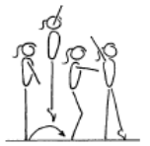 | - square hips and shoulders throughout the skill  - vertical take off  - extended toes, ankles, knees and hips in flight  - both heels on to the Beam on landing  - body vertical during landing
Turns | 1. Straight jump ½ turn
FWO, BWO & Tic Toc | 1. F2-5.1 Stand in front of a wall, perform back arch to contact hands on the wall and return to stand |  | - keep hips in line with feet  - stretch up first then open shoulders to initiate the back arch  - keep gluteal muscles tight  - maintain good body tension and alignment
 | 2. Shoulder stretch with hands on raised surface – shoulders towards ground – no coach pressure

PRE-LEVELS GOLD – BARS (1)
Hanging & Grip Strength | 1. © GF4.1 Hang Sequence. 5 x Hangs each held for 2 seconds – Straight, tuck, star, split, stag
Tuck Swings /Glides | 1. Tuck swings re-grip (assist x 3) with teddy between knees | 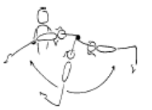 | - gymnast must maintain good body tension and  - alignment
 | 2. B1-3.2 On the spot, jump ‘catch’ the bar | 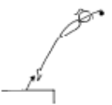 | - show a rounded body position on the jump to catch the bar  - head neutral, chest rounded and hips under
 | 3. © Glide on a roller
Front Support /Casts | 1. B2-3.2 Front support flexion/extension activity with cylinder | 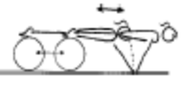 | - arms must stay straight  - head neutral  - maintain good body tension and alignment
 | 2. GF5.9 Seal Walk
 | 3. © Shrugs | 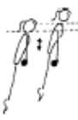 | - straight arms throughout the jump to front support  - chest rounded
 | 4. Jump to front support, push away and return to the bar (cast to clear the bar)
 | 5. B2-3.1 a series (2-3) of small casts to where the body just leaves the bar, coach may assist by supporting shoulders over the bar | 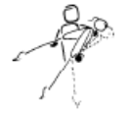 | - arms must stay straight  - head neutral  - fast backward body snap action  - dish shape at the ascent peak phase
Fwd Roll Dismount | 1. B2-1.1 Tuck leg lifts on wedge x 4 | 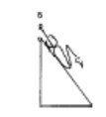 | - maintain good body tension and alignment  - knees to chest
 | 2. Spotted Roll fwd on bar, show tuck hang hold | 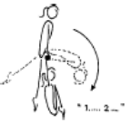 | - straight arms throughout the front support phase  - chest rounded on the bar  - tight tuck in the roll forward  - knees to chest in the tuck hold
Pullover | 1. © B2-1.2 Hold a bar (or rope) in hands, rotate backwards to touch feet on or near the floor | 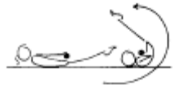 | - keep bar near hips  - legs together  - initiate rotation
 | 2. Holding toes to the bar on own – 7secs
 | 3. Chin up hold on own – 7 secs
 | 4. Swing on rings in tuck position 3 x fwd and bwd (with box under so gymnast remains in tuck position)

PRE-LEVELS GOLD – BEAM (1)
Front support Mount | 1. © M1-1.4 Squat position with a ½ turn | 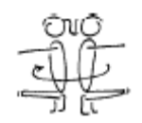 | - arms straight and stretched  - shoulders upright  - balance on balls of the feet  - knees tight together  - turn whole body as a unit  - keep body level, do not bounce up and down
 | 2. Jump to front support straddle over | 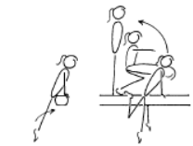 | - straight arms in front support  - legs straight during the first phase  - during the swing to squat, or lift feet behind, keep arms straight and head neutral  - in the squat have shoulders upright and weight on the balls of the feet
Kneeling Scale | 1. Practise kneeling scale position on floor | 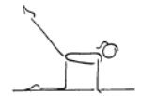 | - arms straight throughout skill  - back leg straight  - head up, eyes down  - square position with arms torso and thigh of support leg  - stable balance
Squat On Mount | 1. Bunny hops over low beam/bench
Arabesque /Posture | 1. M2-5 Low scale L & R
Attitude Steps | 1. M1-5.1 Attitude steps on floor/bench | 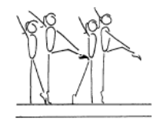 | - one arm moves to low oblique to touch the top of the opposite knee, the other arm repeats the same pattern  - support leg is straight  - the free leg is turned out and the knee is lifted to hip height  - steps are to be performed on toes  - hips under, stomach pulled in  - head up, eyes down  - good rhythm  - stable balance
Releve/Turns | 1. M1-2.1 Releve on the beam – held for 7 sec x 2 | 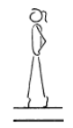 | - one foot slightly in front of the other, both legs slightly turned out  - legs squeezed together  - legs straight, knees locked  - heels pushed forward into a high arch shape  - ankles should be stable  - equal weight on both feet  - maintain good body tension and alignment
 | 2. M1-4.2 Have gymnasts stand sideways on the beam with hands on hips, legs slightly apart, perform a ¼ turn to the left, return and repeat to the right | 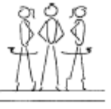 | - ensure square hips and shoulders  - turns to be performed on toes  - good posture
 | 3. © M1-7.2 Hold fwd passé position and releve for 2 sec
Locomotion | 1. Walk on toes (locked legs)
 | 2. © M2-3 Hopping along bench/low beam | 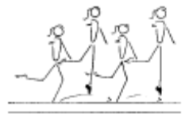 | - good rhythm  - confidence  - good body alignment and control  - εextended toes, ankles, knees and hips
 | 3. M1-3.1 Crab walk on beam
 | 4. M1-3.1 Bunny hops on bench with mat over and crash mat under
Jumps /Leaps | 1. © M1-10.2 Straight jump over small objects (bean bags) – swinging arms | 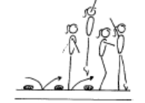 | - ensure efficient use of arms  - ensure shoulders upright at all times  - knee bend should not exceed 45’  - during the jump the toes, ankles, knees and hips must be extended  - hips under and stomach pulled in  - head up and eyes down  - on landing (plie) position arms in front, then present  - emphasise square hips and shoulders during take  - off and landing
 | 2. M1-10.3 On low beam or bench – perform various positional jumps including tuck, star, ¼

PRE-LEVELS GOLD – BEAM (2)
Stride Leap | 1. M3-2.2 Alternate running steps – small step, long step | 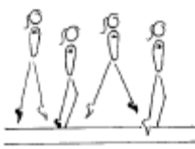 | - arms side horizontal  - square hips and shoulders  - keep body upright
Handstand | 1. © M3-4.1 Front support with hands on a middle beam and feet on a higher box – performed to the front
Landing Drills | 1. Can you move me/ shake me in landing position | 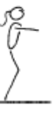 | - on landing the hips must be under  - on landing the shoulders, hips and ankles should all be in a vertical line
 | 2. Clap – don’t jump off beam until coach claps
Straight Jump Dismount | 1. M1-6.1 Straight jump (and other positional jumps) on a trampoline and from a mini tramp to land | 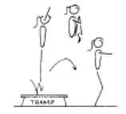 | - vertical take off  - correct position in the air  - control body on landing
 | 1. © M1-6.1 Straight jump (and other positional jumps) off a bench/mid beam to land | 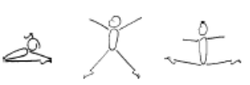 | - vertical take off  - correct position in the air  - control body on landing

PRE-LEVELS GOLD – VAULT (1)
Landing | 1. © GF2.8 Bench/Beatboard Jumps – step from bench, quickly jumping on BB to straight jump and land – focus on arm circle and explosive take-off | 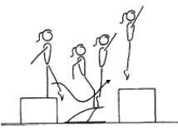 | - underarm action  - arms stop at 45’  - low approach from the box to the board  - feet lead body onto the board  - fast explosive bounce off the board  - vertical bounce off the board  - maintain tight straight body shape, with chest in, on the box
Bounce /Spring | 1. © V1-1 5 x bounces on a board
 | 2. V1-5 Springing circuit – 8 low objects | 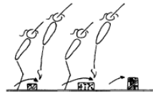 | - maintain good body tension and alignment  - continuous bouncing, no pauses or stops  - easy clearance of the objects
 | 3. V1-4.2 Long Rope Skipping
 | 3. GF3.7 6 x hopping steps on each leg
Running | 1. Running | 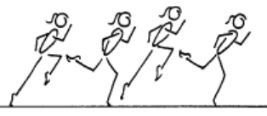 | - good body alignment  - fast action  - arms bent at 90', moving beside body  - legs moving within the body line  - body straight with slight forward lean  - maximum forward speed is essential  - head remains neutral and still
Straight Jump Vault | 1. © Run b/b to straight jump, correct landing on floor
 | 2. V2-4.2 2 or 3 running steps hurdle bounce off the board up the wall
 | 3. Short run, hurdle with arm circle, 2 feet take off, straight jump from spring board to 30cm crashmat or box (*)
Handstand Flatback | 1. © V2-1.2 Shoulder Shrugs in front support | 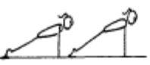 | - head neutral  - maintain good body tension and alignment
Catsprings -Handspring Vault | 1. V2-2.1 Front support with feet raised
Dive Roll / Front Salto | 1. © V2-3 Run along bench, spring off a board, straight jump to land | 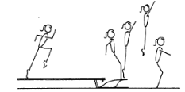 | - bent arms - arms do not drop, or straighten out  - alignment - arms do not swing across body or out to the side  - arms have 90’ bend, lift to eye level and swing back to body line

